24th January 2018

**YOKOHAMA’s Indonesian Subsidiary Receives International Certification for Marine Hoses**

PT Yokohama Industrial Products Manufacturing Indonesia, a group company manufacturing marine products, has received certification that its Seaflex brand marine hoses, which are used for offshore transportation of crude oil and petroleum products, are fully in conformance with international requirements.  
  
The Indonesian subsidiary’s plant was recently certified as compliant with the industry's international requirements established by the Oil Companies International Marine Forum (OCIMF) in its Guide to Manufacturing and Purchasing Hoses for Offshore Moorings, 5th edition (GMPHOM 2009). The plant began shipments of the Seaflex marine hoses in full compliance with GMPHOM 2009 since last November.  
  
Certification of the Indonesian plant means that all three Yokohama Group plants manufacturing marine hoses, including the Hiratsuka Factory in Japan and Yokohama Industrial Products Italy S.r.l., now can supply the Seaflex marine hoses in compliance with GMPHOM 2009.  
  
PT Yokohama Industrial Products Manufacturing Indonesia manufactures marine hoses and pneumatic fenders at its plant located in the Kabil Industrial Estate in the eastern part of Indonesia’s Batam Island.  
  
YOKOHAMA is one of the world's leading manufacturers of products for oil and gas market and aims to further expand its market share through appropriate responses to the robust demand for such products.

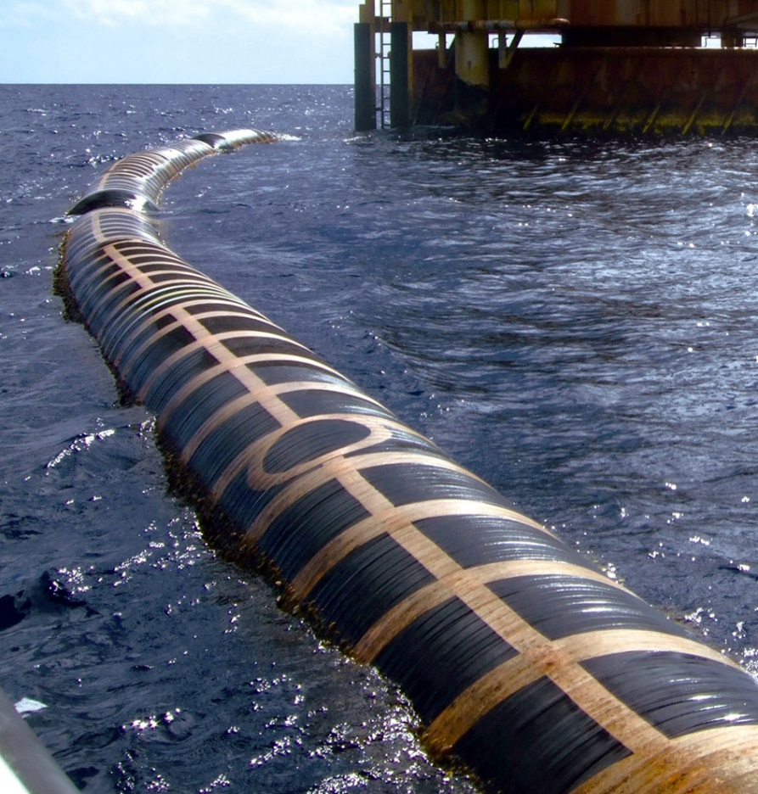

*Seaflex hose transporting crude oil*